**Lab 6 – Nicky Randles – B00058026**

• Explain the goal of the MVC design pattern.

The goal of the MVC design pattern is to separate the model from the way it is shown to the user from the way in which the user controls it.

• What is a design pattern?

Design patterns are recurring solutions to design problems you see over and over.

• Illustrate using a diagram the MVC design pattern

Each aspect of the problem in MVC is an individual object and has its own way of managing its data. The communication between the user, the graphical interface and the data is carefully controlled. This achieved in MVC by separating the functions. MVC allows objects to communicate without become entangled in each other’s data models and methods.

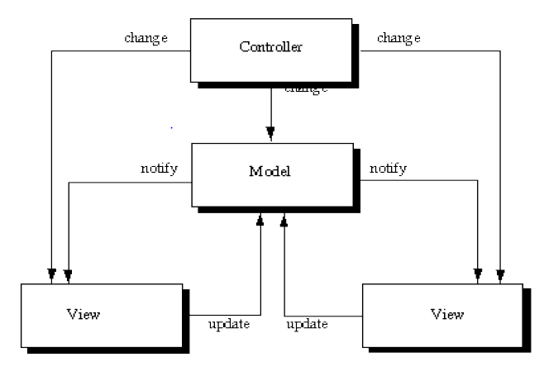

• Explain each of the components of the MVC (Slide 15 and other slides).

The model object knows about all that needs to be displayed and all the operations that can be used to transform the object.

The view object refers to the model. It uses the query methods from the model to get data from the model and display it.

The controller object knows about the physical parts and translates the information send through them into the manipulator method which the model understands. For Example, Mouse and Keyboard.

• Provide two examples of the MVC

– Min/Max data

* The model represents the state of the component.
* The view shows how the component is represented on the screen.
* The controller describes how the component interacts with user.
* The scrollbar uses the information in the scrollbar to tell how far into the scrollbar to bring the thumb and how wide the thumb should be.

– Clock Timer

* The model knows about the all needs to be displayed and all the operations to change the time. The model can provide the view objects with methods which allow them to query the current time.
* One view object could display the time as an analogue clock and another could display is as a digital clock
* He clock can be reset by typing the current time into the digital clock display.

• List six advantages of the MVC?

1. Multiple views using the same model: Because of the separation of the model and view, we are able to make multiple views using the same model.
2. Easier support for new types of clients: You can support a new type of client by writing a view and controller for it and the wirings them into the already created enterprise model.
3. Clarity of design: By looking at the model’s public method list ,we are able to understand how to control the models behaviour better. This makes it a lot easier for us to design the application
4. Efficient modularity: This allows us to swap in and out any components as we desire.
5. Ease of growth: Controllers and views can grow as the model grows. Older versions of the controllers and views can be still used if a common interface is maintained.
6. Distributable: By using a couple of proxies we can distribute any MVC application by changing the start-up method of the application.

• Swing introduced UIs to the traditional MVC – explain this modification referring to

Look and Feels (LnFs)

Swing introduced several sets of UI delegates to the MVC. Each set contains ComponentUI implementations for most Swing components and we call each of these sets a look and feel implementation.